Chapter 10, Solution 24.

Design a problem to help other students to better understand mesh analysis.

Although there are many ways to work this problem, this is an example based on the same kind of problem asked in the third edition.

Problem

Use mesh analysis to find V_{o} in the circuit in Prob. 10.2.

Solution

Consider the circuit as shown below.
2 Ω
+
_
+

I₁ j4 Ω V_{o}
4∠0º V –j5 Ω
I₂
–

For mesh 1,
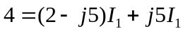 (1)
For mesh 2,
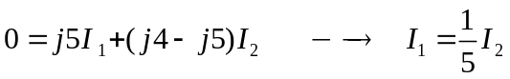 (2)
Substituting (2) into (1),

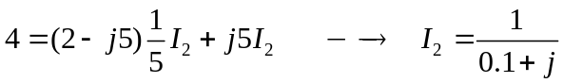

V_{o} = j4I₂ = j4/(0.1+j) = j4/(1.00499∠84.29°) = 3.98∠5.71° V

